# System Architecture Design

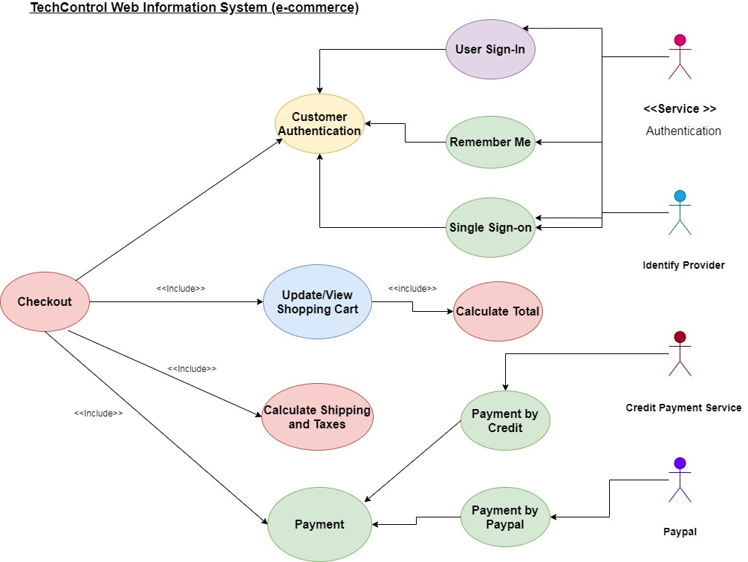**Figure 1: System architecture diagram of TechControl business of e-commerce**

A system architecture diagram can be considered for showing the relationship existing among various components. Generally, these can be created for systems while including hardware and software which can be represented in the diagram for showing interaction among them. It is also considered for creating web applications. The system architecture diagram for TechControl shows the entire process of Customer Authentication, Update/View Shopping Cart, Calculate Shipping and Taxes and Payment. This process can be categorized as User Sign-In, Payment by Credit and many more. Service, Identity Provider, Credit Payment Service are the most significator actors for system architecture design.